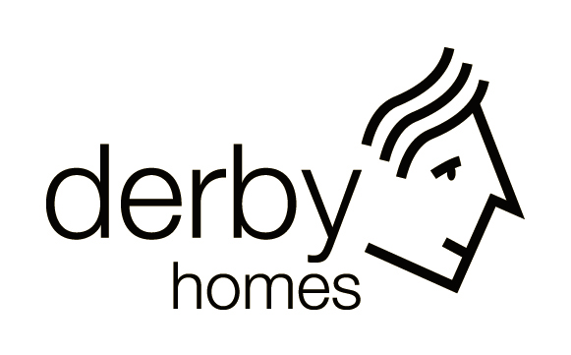

Anti-Social Behaviour
Policy

Contents

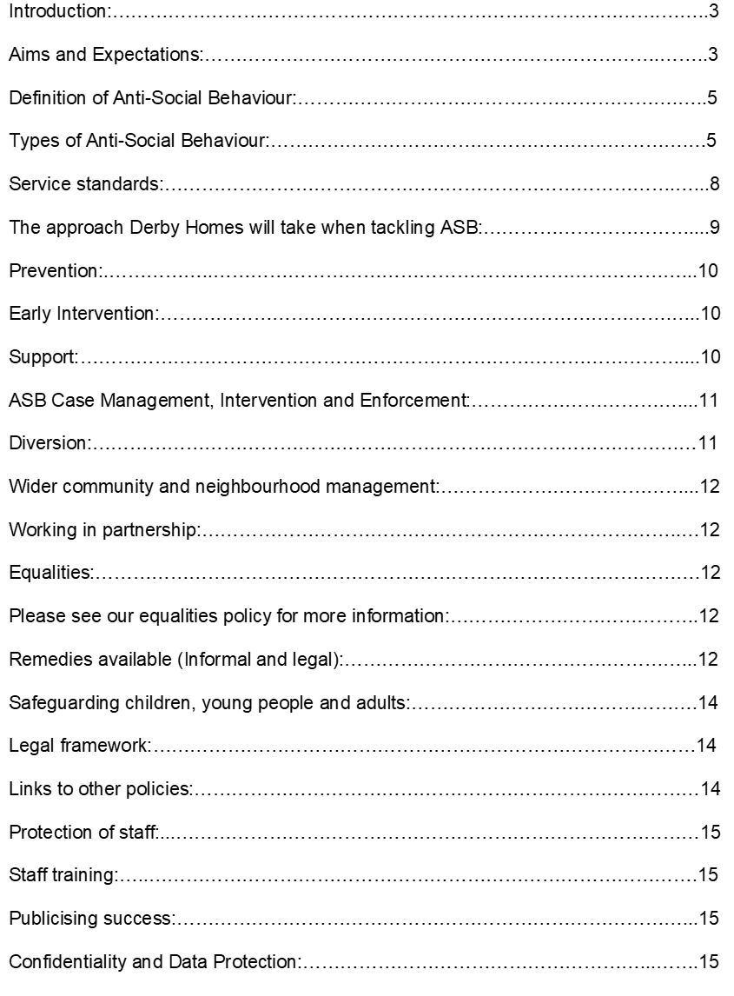
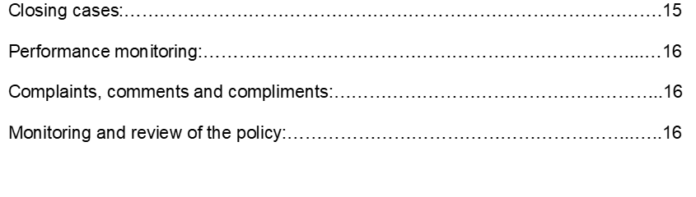

Introduction:

Derby Homes’ aim is to deliver a high quality, value for money housing service for Derby. We support our tenant’s statutory right to live peacefully and enjoy the security of their home.

Anti-social behaviour ( ASB) covers a range of nuisances, disorder and crimes which affect people’s lives from noise nuisance, vandalism and graffiti, to drunk or rowdy behaviour, intimidation and harassment. This list is not exhaustive. If left unchallenged anti-social behaviour can have huge impacts on the lives of our tenants. Anti-social behaviour, of any kind, is unacceptable.

As a responsible landlord we aim to tackle anti-social behaviour swiftly and effectively. We will use a range of methods to achieve swift resolutions for victims. We will take a pro-active approach to preventing anti-social behaviour as well as resolving it where it occurs. We take a victim centred approach, tailoring our responses to the needs of victims.
We understand that sometimes, perpetrators of anti-social behaviour also need help. Sometimes they are not aware of the impact of their behaviour on others. Sometimes they need help to change. In addition to supporting victims and tackling anti-social behaviour, where appropriate, we will work with perpetrators to influence behaviour change, both through our own interventions, and through working closely with outside agencies.

This policy has been developed in line with the Housing Act 1996, the Crime and Disorder Act 1998 (as amended) and the Anti-Social Behaviour Act 2003, further amended by the Anti-social Behaviour, Crime and Policing Act 2014,including any subsequent amendments to the 2014 Act.

Aim and Expectation:

Our aim is to ensure that we provide great homes in great neighbourhoods. To this end we have developed a set of expectations to determine how we deal with complaints of anti-social behaviour. These are listed below:

- We have zero tolerance approach to anti-social behaviour in our neighbourhoods. This means that when anti-social behaviour is reported to us, we will always act promptly and in line with our procedures and service standards.

- We encourage residents to tell us about anti-social behaviour by making sure our reporting process is clear and easy to access for all our customers, and we take a proactive approach to communicating with residents. For instance, we offer help for tenants who prefer to receive information in different formats and ensure that there are a variety of ways in which to report incidents.

- We carry out Risk Assessments of all victims, underpinning our Victim Centred Approach. Information regarding victims identified as medium or high risk are shared and discussed with the Police and other agencies and information is shared through our shared E-CINS ASB recording system (Empowering Communities Inclusion & Neighbourhood Management System).

- In conjunction with Derbyshire County Councils Anti-Social Behaviour Partnership, Derbyshire Police and Crime Commissioner’s Office, Derby Homes also offers and refers Victims of ASB through to Derbyshire Victim Services (REMEDI UK).

- Specific joint actions to protect victims identified as being at risk are put in place. Risk assessments are regularly reviewed and updated where necessary.

- When residents report anti-social behaviour, we will explain what action we will take and provide as much help and advice as needed to support them throughout their experience of anti-social behaviour.

- We will work with perpetrators of anti-social behaviour, recognising that it is possible to change core behaviour to the point where it becomes acceptable.

- We will ensure we are always compliant with the latest national standards and any future regulatory frameworks, and closely monitor the quality and effectiveness of our service by setting challenging performance targets for staff, based on effective outcomes.

- We will monitor customer satisfaction with our service by carrying out a telephone, email or postal survey as preferred by the customer on all customers when their complaint of anti-social behaviour has been closed. This will further feed into future tenant satisfaction measures being brought in nationally across the Housing Sector.

- Where dissatisfied customers are identified, we will contact them to understand and learn from their experience, implementing changes to our practices where appropriate.

- We will regularly review the effectiveness of our practices to ensure that we provide the best response possible.

- We recognise that prevention is better than cure. We adopt a partnership approach in dealing with anti-social behaviour and take action that is appropriate and proportionate to the specific complaint.

- We promote early intervention to resolve anti-social behaviour complaints as quickly as possible. This is because dealing with things before they escalate means they are much more likely to be resolved. It is also much less expensive in terms of officer time and other costs if cases do not have to be resolved formally. There are many forms of early intervention, the most important one being timely contact with victims and alleged perpetrators of anti-social behaviour.

- We will seek out good practice through attendance at regional and national seminars regarding anti-social behaviour, and will invest in the professional development of our staff to equip them with the necessary skills and knowledge to deal effectively with anti-social behaviour on our estates. Derby Homes are Corporate members of RESOLVE ASB, a National Organisation, advising and representing Housing, Local Authorities and ASB Providers on matters of Home Office Policy, good practice , guidance and training around ASB and Community Safety.

Definition of Anti-Social Behaviour:

The Anti-Social Behaviour Act 2003 defines anti-social behaviour is any conduct to which sections 153A (1) and 153B (2) of the Housing Act 1996 Act apply. These sections apply to conduct which:

- Is capable of causing nuisance or annoyance to any person; and
directly or indirectly relates to or affects the housing management functions of a relevant landlord; or

- Consists of or involves using or threatening to use housing accommodation owned or managed by a relevant landlord for an unlawful purpose.

The Anti-Social Behaviour, Crime and Policing Act 2014 was introduced to streamline the existing tools and powers available to deal with Anti-Social Behaviour. Home Office guidance says that:
Anti-social behaviour is a broad term used to describe the day-to-day incidents of crime, nuisance and disorder that make many people’s lives a misery – from litter and vandalism, to public drunkenness or aggressive dogs, to noisy or abusive neighbours. Such a wide range of behaviours means that responsibility for dealing with anti-social behaviour is shared between a number of agencies, particularly the police, councils, and social landlords.
Consequently, we have information sharing agreements and systems in place in order to work together.
Anti-social behaviour can threaten the physical or mental health, safety or security of individuals, groups and communities and, as a result, undermines people’s human rights.

Types of Anti-Social Behaviour:

We put all incidents of anti-social behaviour reported to us into categories, assessing both the risk and seriousness of the alleged behaviour, and the impact it is having on the victim. If an incident is made up of several types of anti-social behaviour, we will treat the most serious part of the complaint first.

Anti-social behaviour may or may not amount to a criminal act. What is important in defining anti-social behaviour is the effect of the behaviour on others. The 2014 Act defines ASB in three different categories-
Personal - behaviour that targets a particular individual or specific group or is aimed at having an impact on a particular individual or incident rather than a community at large.
Nuisance - individuals or incidents that cause trouble, annoyance, inconvenience, offence or suffering to people in the local community in general, rather than targeted at an individual.
Environmental - incidents and inconsiderate actions which impact on the surroundings including the natural, built and social environments.

The following categories of anti-social behaviour have been adopted by Derby Homes:

Category 1 – response within one working day:

Very serious complaints, and those where risk to the victim is considered to be high, are categorised and prioritised as Category 1.This is our highest classification of anti-social behaviour where Derby Homes believes that a person may be in danger and urgent action is required to protect them. Some examples of category 1 complaints are given below:

- Harassment / intimidation / threatening behaviour
- Domestic abuse – Derby Homes has a separate Domestic Abuse Policy
- Physical violence

Hate Crime and Hate Incidents

There is a distinct difference between a hate incident and a hate crime.

A hate incident is defined as:

‘Any incident, which may or may not constitute a criminal offence, which is perceived by the victim or any other person, as being motivated by prejudice or hate.’ - Home Office & Association of Chief Police Officers (ACPO) 2005.

A hate crime is defined as:

‘Any hate incident, which constitutes a criminal offence, perceived by the victim or any other person, as being motivated by prejudice or Hate crime.’ – Home Office & ACPO 2005.

Derby Homes recognises the serious effects of hate incidents, hate crimes and racial harassment on victims who experience it. Derby Homes is committed to tackling this problem by supporting victims, dealing with the perpetrators and taking measures to prevent further incidents, crimes and/or harassment occurring.

Derby Homes recognises that small numbers of hate incidents are currently reported to them and that most hate incidents reported are racial harassment. Derby Homes however also understands that reports of hate incidents are increasing throughout the County.

Hate related incidents -the definition of a hate crime or incident is an incident that is perceived as such by the victim or another person. Examples of hate crime or incident could be because of someone’s religion, belief, gender, sexuality, transgender identity, mental health, learning or physical disability, race, cultural difference or because they have HIV/AIDS. In addition Derby Homes have also adopted another strand of hate crime – “alternative sub culture”.

Derby Homes operates as a Hate Crime reporting and signposting service we also ensure that victims are given guidance and advice on contacting specific Hate Crime Support Services and agencies.

http://dhnet/contdocs/External Documents/SHUK Hate Incident Reporting and Signposting Handbook.docx
http://dhnet/contdocs/Externa Documents/Derby Hate Crime Support Agencies.docx.

Category 2 – response within five working days:

- Drugs, substance misuse, drug dealing
- Noise
- Verbal abuse
- Vandalism and damage to property
- Alcohol related incidents
- Prostitution, sexual acts, kerb crawling, loitering
- Other criminal behaviour
- Misuse of shared areas and public space
- Pets and animal nuisance
- Nuisance from vehicles
- Litter, rubbish, fly tipping
- Garden nuisance (when we have received a complaint). Derby Homes ASB Team will support other Housing Management staff in addressing serious Garden Nuisance using “Community Protection Legislation” particularly “Community Protection Warnings”.

If the property where the victim/witness lives has been the subject of vandalism or graffiti, we will deal with this as a matter of urgency.

Service standards:

We have clear service standards when dealing with complaints which have been developed with our residents.

- We will provide regular updates to communities about actions taken to tackle anti-social behaviour. In particular we will publicise, where permitted, enforcement actions such as, anti-social behaviour Injunctions and other legal actions to encourage victims to report anti-social behaviour, and as a deterrent to others.

- Derby Homes will publicise a ‘zero tolerance’ approach to ASB in Derby Homes News and on its website.

- We will provide comprehensive support and help for victims and witnesses of anti- social behaviour, having regard to those identified as being vulnerable.

- We will take complaints of anti-social behaviour seriously; grading each reported incident and responding in agreed timescales (all serious incidents of anti-social behaviour being responded to within 1 working day), recording and investigating them all, providing regular updates to all involved parties.

- We will respond swiftly and effectively; providing multi agency responses where necessary to incidents of Environmental Crime and location based Anti-Social Behaviour issues.

- We will work closely with Neighbourhood Policing Teams and a range of other local partners including Community Mental Health Services, Adult Social Care, Derby City Council Community Safety Team and Neighbourhood Partnership Officers as well as Local Area Coordinator Teams to deal swiftly and effectively with anti-social behaviour problems.

- Whilst addressing community concerns, we will ensure that the support needs of those who perpetrate anti-social behaviour are addressed and that they are afforded adequate opportunity to moderate their behaviour, leading to the best possible outcomes for all.

- We will work with the Police and other local partners to reduce re-offending by young people and to deter young, prolific or priority offenders from further anti-social acts.

- We will celebrate the positive actions of young people in Derby, in preventing them becoming involved in ASB.

- We will inform all new tenants of Derby Homes’ policy on anti-social behaviour. Conditions of tenancy and expectations of new tenants will be explained at sign-up. They will be provided with a copy of the ‘you and your neighbour’ leaflet. Introductory tenants will be advised at sign-up of the special conditions with regard to their new tenancy.

- We will respond to all complaints of anti-social behavior within a maximum of 5 working days, advising complainants who their main contact is.

- We will agree an appropriate action plan with complainants of anti-social behaviour to ensure that action is progressed and recorded.

- We will keep accurate and detailed records of incidents.

- We will report all criminal behaviour, damage and vandalism cases to the police and pursue the costs, if necessary, through court action, where the perpetrator is known.

- We will agree the frequency of our contact with complainants of anti-social behaviour when a case is opened and will record this on the action plan.

- We will work alongside Social Services, the Housing Options Team and all other appropriate support services in cases where evictions are being considered to discuss risk, agree actions and wherever possible prevent homelessness.

- We will seek to recover court costs awarded as a result of evictions or other enforcement action.

- We will provide residents with a wide variety of ways to report anti-social behaviour to ensure that everyone is able to access help quickly and easily.

- We will also proactively encourage the reporting of anti-social behaviour incidents through regular newsletter articles, information leaflets, and at surgeries and events held in our neighbourhoods.

- We will operate a hate crime reporting and signposting service across all of our Local Housing Offices.

The approach Derby Homes will take when tackling ASB:

- In line with the latest national standards and any future regulatory frameworks, Derby Homes’ approach to tackling anti-social behaviour focuses on prevention, early intervention, support, enforcement and diversion. Derby Homes will closely monitor the quality and effectiveness of our service by setting challenging performance targets for staff, based on effective outcomes. This holistic approach is delivered through agreed partnership arrangements.

We will not move complainants or alleged perpetrators who are tenants as a means of resolving anti-social behaviour (except in exceptional circumstances); we will deal with the problem.

The action that we take will be reasonable and proportionate to the type of anti-social behaviour that has been reported.
We want to create a climate where people feel confident in coming forward with information. However, where complainants wish to remain anonymous, we will still investigate the complaint, but action may be limited.

Prevention:

Derby Homes recognises that prevention is an important element of tackling anti-social behaviour in neighbourhoods. We will work closely with internal and external partners to prevent anti-social behaviour from occurring. Our range of partnership based preventative work is aimed at reducing the overall cost of ASB both to Derby Homes and other Council and partner services

Early intervention:

It is essential when dealing with complaints effectively to intervene at an early stage and tackle problems quickly to prevent them from escalating. Evidence shows that early intervention is by far the most cost-effective way of resolving complaints. National Audit Office figures from 2006 suggests warning letters can cost around £66, and an Acceptable Behaviour Contract (ABC)around £250 but an injunction around £3,000. Derby Homes estimate that a possession order, with all of the associated void costs can cost upwards of £10,000

Early Interventions may include the following:

- Verbal warnings
- Written warnings
- Issuing of Community Protection Warnings ( CPW)
- Mediation delivered internally or by a partner agency.
- Referrals to partner agencies for a variety of reasons- i.e. Diversionary Activities / Mentoring programmes etc.
- ABC including working in partnership with other agencies- i.e. Youth Services/ Police etc.

Support:

Providing support either alongside enforcement action or on its own is critical in changing behaviour in the long term.

We have access to various services that are delivered either internally or in partnership with others to provide support to both complainants and alleged perpetrators of anti-social behaviour, some of which are listed below:

- Victim and Witness Support

- Intensive Housing Management Services / Complex Needs / Intensive Intervention Services and general Tenancy Sustainment Services.

ASB Case Management, Intervention and Enforcement:

Derby Homes has a team of specially trained and qualified staff who deal with all aspects of anti-social behaviour. Anti-Social Behaviour Officers’ aim is to tackle and reduce anti-social behaviour by supporting victims and taking positive action against perpetrators of anti-social behaviour. All ASB Staff are trained to BTEC Level 5 Advanced Award in ASB, Community Safety, Crime and Nuisance Management for Practitioners.

The team have access to ongoing learning and development around Safeguarding – ASB and other related training.
The team is a decentralised team working within the neighbourhoods across Derby City as part of the local housing team.

Diversion:

Derby Homes works alongside partners in the city to identify ways that they can successfully divert people away from committing anti-social behaviour and engage them in meaningful activity.

Adults who are referred to the Local Area Coordination team will be helped to identify activities they are interested in and given support so that they can integrate into the community.

Derby Homes supports the delivery of the Children & Young People strategy across the city to fund positive diversionary activities.

Derby Homes ASB Team will identify young people at risk of - or who are involved in low level crime and anti-social behaviour and make referrals into projects that are operating at any given time.

As well as being key partners of Derby City Council’s Stronger Communities Board, Derby Homes are also members of the Youth Alliance, (a sub-group of that board) working to align funding and youth provision across Derby City. The Youth Alliance is a cooperative cohort of parties whose aim is to reduce risk and improve wellbeing and services for young people in Derby. The Youth Alliance is currently carrying out a pilot project which Derby Homes have funded. This is delivered through interventions which are preventative and/or diversionary for those at risk of anti-social behaviour and crime in homes and estates that they manage. Derby Homes works closely with Derby City Council and other partners to mitigate the impact of serious crime on its estates. If the project proves successful Derby Homes will consider contributing a more substantial amount of funding so the project can be expanded.

At present Derby Homes are also providing some funding to the YMCA to develop a pilot project. The YMCA are an independent charity committed to helping people at times of need. They provide units of accommodation to the most vulnerable young people across Derby. Derby Homes supports YMCA with a community-based mentoring and engagement pilot which includes intensive support, mentoring and community-based activities through sports, music and art. The Innovation Project is delivered through a dedicated team working across three organisations which include Derby County Community Trust and Baby People. The ambition of the project is to help all young people with a history of ASB to engage with diversionary activities and improve well-being and educational attainment. It is hoped that if successful the YMCA will identify alternative funding streams so that the project becomes sustainable.

Wider community and neighbourhood management:

Derby Homes now work to the latest national standards and any future regulatory frameworks that may apply, in order to demonstrate to the wider community our commitment to do everything reasonably possible to tackle anti-social behaviour and deliver a high quality service.

The ways in which residents can report anti-social behaviour to us are outlined on our website. Non council tenants and owner occupiers are able to access this information and report anti-social behaviour. Derby Homes will take action against residents who are not tenants when necessary working in partnership:

Partnership working is vital if we are to minimise anti-social behaviour and tackle it when it does occur .The aim is to: “Prevent and reduce harm caused to communities and individuals in Derby by anti-social behaviour through engaging people and partnership working.”

Equalities:

We work in accordance with the Equality Act 2010 to assess whether alleged perpetrators are vulnerable so that we can identify the most appropriate support to help them to change and modify their behaviour.

Please see our equalities policy for more information

Remedies available (Informal and legal):

Most complaints of anti-social behaviour will not require legal action and will be quite effectively resolved through early intervention by the ASB Team

Informal means of resolving anti-social behaviour may include:

- Verbal and Written Warnings
- Home visits
- Joint Police visits
- Mediation
- Acceptable Behaviour Contracts
- Good Neighbour Agreements
- Community Protection Warnings
- Parenting Contracts
- Referrals into Derby Homes Tenancy Sustainability Services
- Referrals to partner agencies for a variety of reasons- i.e. Diversionary Activities / Mentoring programmes etc.
Use of Family Intervention Tenancies

Legal means of resolving Anti- Social Behaviour, including provisions provided under “ASB Crime and Policing Act 2014, Housing Act 1996 & the Crime and Disorder Act 1998

- Notices of seeking possession
- Civil Injunctions.
- Demotions.
- Possession.
- Court undertakings.
- Abatement Notices.
- Criminal Behaviour Order – aimed at tackling serious and persistent offenders where their behaviour has brought them before a criminal court. This power is only available to Derby City Council or Police, however Derby Homes will work in partnership on this if necessary.
- Dispersals – will be used by police to remove any person committing or likely to commit anti-social behaviour, crime or disorder to leave an area for up to 48 hours. This power is only available to the Police, however Derby Homes will work in partnership on this if necessary.
- Community Protection Notice (CPN) – stops a person 16 years and over, a business or organisation committing anti-social behaviour, which spoils the community’s quality of life. Derby Homes have a specific “Memorandum of Understanding “in place with partners at Environmental Protection, Communities Environment and Regulatory Services-Department Communities and Place Directorate. This has been in place since April 15, it was revised and updated in 2018 and is still fit for purpose. This enables Derby Homes and DCC to work jointly on cases of noise nuisance and general ASB where “Community Protection Legislation can be adopted. Derby Homes do not have statutory powers to use this legislation, however we do issue “Community Protection Warnings” and then work with DCC to enable them to issue Community Protection Notices, on breach on any suitable cases.
- Public Spaces Protection Order – This aims to stop persons or groups committing anti-social behaviour in a public space. This power is available to Derby City Council; however Derby Homes will work in partnership on this if necessary.
- Closure powers – allows the Police and Council to quickly close premises, which are being used for illegal or immoral purposes. This power is only available to Derby City Council or Police however through greater working partnerships with those agencies we can access these powers.
- Absolute Ground for Possession – possession of secure and assured tenancies, where anti-social behaviour or criminality has already been proven by another court – ie Crown or Magistrates Court.
- The Community Trigger – allows the public to challenge public bodies to account for their response to anti-social behaviour. Derby City Council is responsible with any partners involved to administer any Community Trigger within the City. Derby Homes has its own Community Trigger Statement on its website
- Community Remedy - The Community Remedy will include a list of actions which might be appropriate for anyone who has engaged in anti-social behaviour or has committed an offence which can be resolved without court proceedings. It is designed to introduce simpler and more effective powers for tackling low level crime and anti-social behaviour. The Community Remedy is also designed to provide victims (should they wish it) a say in the sanction an offender receives if the crime warrants an out of court settlement. This primarily works on Restorative Justice Principals.

Safeguarding children, young people and adults:

We proactively participate in partnership arrangements to safeguard young people and vulnerable adults. Derby Homes has a separate Safeguarding Policy and Procedure

In dealing with anti-social behaviour, hate crime and incidents, full consideration will be given to our safeguarding responsibilities.

Legal framework:

The legal framework for dealing with anti-social behaviour is outlined below:

- Equality Act 2010
- Human Rights Act 1998
- Homelessness Act 2002
- Data Protection Act 2018 and the General Data Protection Regulation 2016
- Housing Act 1985
- Housing Act 1996 (as amended by the Homeless Act (2002)
- Environmental Protection Act 1990 and the Statutory Nuisance Act 1993
- Anti-Social Behaviour Act 2003
- Housing and Regeneration Act 2008
- Anti-Social Behaviour, Crime and Policing Act 2014.

Links to other policies:

Other strategies/policies that support or influence this policy include

- Homelessness Strategy
- Allocations Policy
- Domestic Abuse Policy
- Equality and Diversity Policy
- Safeguarding Policy
- Complaints Policy

Copies of these policies are available on request or can be downloaded from our website.

Protection of staff:

We will take firm action if staff are threatened or abused, including legal action which can result in an injunction, demotion of a tenancy, or even possession proceedings.

Staff training:

Tackling anti-social behaviour effectively requires our staff to be knowledgeable and well trained. We will make sure that all staff dealing with anti-social behaviour clearly understand their roles and responsibilities.

Publicising success:

Publicity is essential if local communities are to support us when tackling anti-social behaviour. Therefore, we will publicise successful results of both legal and non-legal actions that we have secured through our partnership working in Derby Homes News, the local media and other publicity outlets. Our website will also be regularly updated with cases where action has been taken to tackle and resolve anti-social behaviour.

Confidentiality and Data Protection:

We respect the rights of our customers to confidentiality and will always request their permission before sharing any information they give us with others.

We will comply fully with the requirements of any new or existing relevant legislation.

Closing cases:

We will close cases where:

- the situation has been resolved and the complainant is in agreement with case closure
- the impact of the anti-social behaviour has significantly reduced
there is insufficient evidence for action to be taken, often this will apply in cases where neighbours do not get along and they make counter allegations against each other and neither party can adequately evidence that the other is to blame. This is a fairly common issue and is experienced across Derby Homes Stock.

We will not assume that a situation has improved if we have not heard from the complainant in a while. We will attempt to make contact with the complainant before closing the case. Only after several failed attempts have been made to make contact will we close the case under the grounds of ‘no contact’.

In certain circumstances, we will close cases even if the complainant does not want us to. However, this will only happen after discussion with the complainant and the reasons for doing this have been fully explained, and we are satisfied that we have done everything we can that is reasonable and proportionate to resolve the complaint. We will record the reasons for closing cases and advise people about what they can do next.

If the complainant fails to respond to our request for information, we will close the case and advise the complainant of this.

Performance monitoring:

All anti-social behaviour cases are regularly audited by the ASB Manager to ensure procedure compliance.

There are a number of performance management processes now in place to assist and monitor case work and performance. This is particularly focused around Risk Management and Action Planning for ASB cases with complainants.

Performance data is benchmarked and reviewed quarterly through Housemark, to ensure we understand how well we are doing when compared to other similar organisations, and to learn from those that are performing well.

Complaints, comments and compliments:

We are always keen to learn what our customers think about the service we provide. We will use the feedback we receive to help us identify areas for improvement.
Comments, complaints or compliments can be made through our website.

Monitoring and review of the policy:

We will consult with customers, staff and internal and external partners in the periodic review of this policy.

