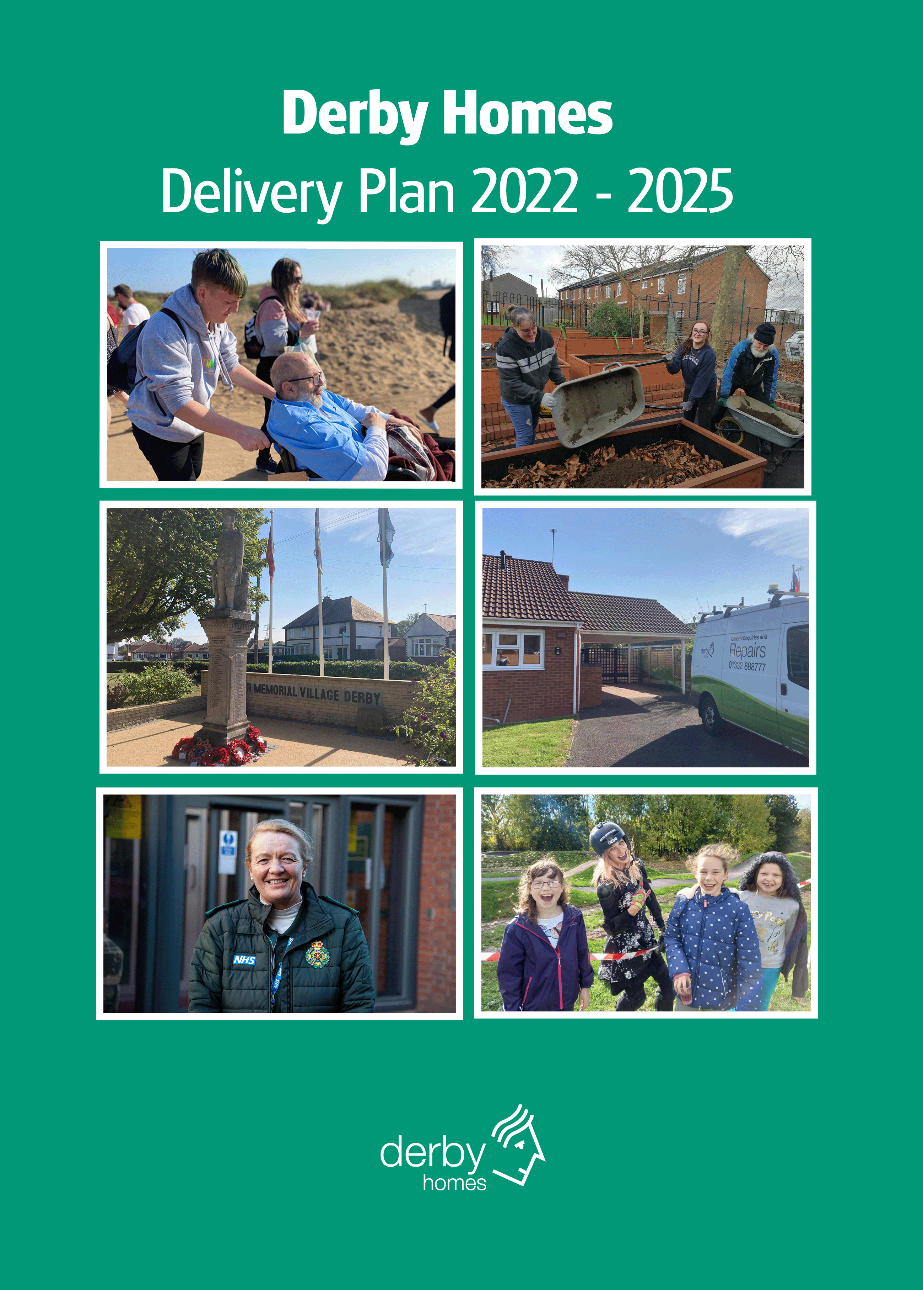

Contents

Executive Summary 3
Derby Homes – Delivering for Derby 4
Mission, Values and Strategic Objectives 5
Mission 5
Values 5
Our strategic objectives: 6
Performance Management Framework 6
Better together – delivering for Derby #TEAMDERBY 6

Executive Summary

There are many positive things about the services that Derby Homes provides. We are an organisation with ambition and drive and have a proud history of achievement. We are committed to listening to our customers, being responsive and supporting our customers and communities to achieve the best outcomes to meet their needs.

The last two years has been challenging for all sectors, as we work to respond to and recover from the COVID-19 pandemic. This has also presented us with many opportunities. We have looked for new ways to work together across the city with the Council and partners by recognizing that as one we can deliver more – we are better together. We have delivered at pace, focusing on our communities first, and have been creative to deliver better outcomes.

This year we have taken the decision to change the format of our Delivery Plan, seeking to ensure that we mirror four key focus areas of the Council, this change will show at the highest level how Derby Homes is working to improving outcomes with the city, for the city.

We are also seeking to be as efficient and effective as we can, working smarter, to deliver value for money for our customers and stakeholders.

There are however significant challenges to maintaining our services. The impacts of the pandemic have increased demand and had an impact on many of our services. Our focus is to work with the Council and other partners to meet these challenges and continue improve services and outcome for our customers.

It is also important that we recognise the requirements within the Housing White Paper, the focus on high service standards and proactive regulation of the sector, the emphasis being on what matters to tenants the most. And of course, the Housing Safety Act 2022, legislation which will come into force over the next 12-18 months, rightfully designed to ensure that tenants live in safe, well-managed homes. These considerations and actions have been woven into the Delivery Plan and translated into our desired outcomes. There is a separate working action plan in relation to our wider review of the Consumer Standards.

We also need to concentrate on our employees, they are the reason that Derby Homes is a high performing organisation and over the course of the next few years we need to recognise that they, along with our customers will face the economic, social and wellbeing challenges that the Country faces as we emerge from a global pandemic.

Maria Murphy
Managing Director

Derby Homes – Delivering for Derby

The table below shows the Council’s key outcome areas and briefly outlines how Derby Homes will make a positive contribution. There is more detail in the theme led sections later in this document.
Green city |  | For a compact city we have a lot of green spaces. In the face of climate change we will lead communities and partners to make a difference.  We will work together as a city to tackle the climate change emergency, promoting more sustainable ways of living, in particular aiming to make our homes, greener, warmer and more affordable for our tenants.
City of growth |  | Our city is home to some significant employers, and we have a strong history of manufacturing and innovation. We want to diversify and grow. Our ambition is to be a smart, super connected city that has the right skills, jobs, and space for the future.  We will continue to support individuals through our successful apprenticeship scheme, working with schools and colleges to promote this as an opportunity of choice. Working with partners we will encourage opportunities for our tenants to enter employment and training.
Vibrant city |  | Derby is a historic city and a UNESCO world heritage site. We are putting culture at the heart of the city, reinvigorating our city centre and developing our cultural offer.  We will work with our partners to ensure that culture is accessible to all our communities and encouraging our offer to be reflective of our citizens needs and desires.
Resilient city |  | There are over 4,000 community and voluntary groups in Derby. Building on our strong sense of pride and community, we’re determined to reduce inequalities and improve health and wellbeing across the city, unlocking the potential within our communities.  We are well placed within communities, supporting some of our most vulnerable citizens to access opportunities helping them to unlock their individual potential.

Working smarter
These four priority themes are supported by two enabling programmes of ‘better together’ and ‘working smarter’; which are the focus of our improvement and transformation activities.

Mission, Values and Strategic Objectives

Mission
Our mission is to provide:

“High quality services for people, homes and communities”

This supports the Council’s vision for Derby, which is to be:

Better together… better outcomes for the city, with the city

Values
Our core values are clear in everything we do, and how we operate. We expect our Board and employees to follow our core values, which serve as guidelines for our conduct and behaviour to help us achieve our mission.

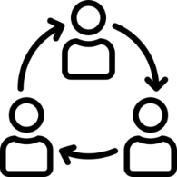  Attitude – We embrace a culture that puts our customers first, adopting a practical and innovative approach to delivering our services  Resilience – We adapt to changing situations, with a clear focus on prioritising what our customers need.  Co-delivery – We recognise the strength of effective partnerships | Engagement – Customers are represented at every level of our organisation  Equalities - We strive to understand and enable personalised solutions that meet the needs of our communities  Excellence - We pride ourselves in striving for excellence  Good Employer – We value our employees  Integrity - We are open and honest, and we aim to keep our promises  Learning - We improve our services by listening to feedback and learning from others  Value for Money - We manage our services efficiently, effectively and economically  Work Safely - We prioritise health and safety for customers and staff.

This Plan and our Strategic Objectives gives Derby City Council assurance that we are delivering across all areas of our Management Agreement for housing services on their behalf.

Our strategic objectives:

 | Strategic Objective 1 | Service that puts our customers first
 | Strategic Objective 2 | Quality homes and contributing to sustainable communities
 | Strategic Objective 3 | Reducing homelessness and enabling access to affordable housing
 | Strategic Objective 4 | Value for money is a consideration in everything we do

Performance Management Framework

Performance measures are helpful to manage services appropriately and to spot trends and take effective action to counteract any emerging issues and help to meet objectives. We will ensure oversight on performance through:
- Discussions at service team level via team meetings, one to one’s etc
- Review of KPI’s at Senior Management Team meetings
- Quarterly reporting through to Operational Board and main Board
- Reporting to the Strategic Partnership Board (DCC & DH) on Delivery Plan progress and by exception, any wider issues relating to changes required to the Partnership Agreement.

Better together – delivering for Derby #TEAMDERBY

To ensure that we are focused on the right things, this section of our Delivery Plan highlights where we will work collaboratively to delivery better outcomes for the city. We are focusing on outcomes because, whilst objectives or actions are often easier to achieve, outcomes will enable us to focus on making a real difference for our city and citizens. Our more detailed actions and progress against them will be measured through our service plans and commentary will be provided through our established reporting framework to the Board and Council.

Our delivery is focused on a targeted number of must dos, each sitting alongside the Council’s key outcome objectives. A summary of our key priorities and the differences we are seeking to make are set out on the following pages.

This plan sits alongside our Medium-Term Financial Strategy and Asset Management Strategy which sets out how we are going to use our resources to achieve outcomes. Our Risk Register sets out the threats that we have identified that could stop us from achieving our goals if not mitigated, alongside any opportunities that we may seek to take.

GREEN CITY
Quality homes and contributing to sustainable communities
and protecting our environment

Our outcomes | Our 2023/24 agreed areas of focus | The differences that you will see
Cleaner air and lower CO2 emissions  Sustainable waste & transport  Enhancing our green and blue spaces | - Contribute to the delivery of the City’s Climate Change Strategy which is underpinned by an action plan to include a variety of cross cutting climate commitments  - Electrification of van fleet  - Evaluation of alternative heating systems  - Green specification for New Homes  - Improve standards for existing homes  - Improve recycling rates and work with suppliers to reduce unnecessary waste  - Monitor current standards on grounds maintenance | An annual reduction in CO2 (carbon dioxide) emissions for both the Council and City to net zero by 2035  Action plan to reach nett zero carbon for both DH and the housing stock  Reduction of fuel use & CO2 emissions  Reduced carbon emissions from residential dwellings through actions to improve energy efficiency/affordability.  Reduction of non re-cycleable materials such as hard plastics.  Improved appearance of estates increasing wellbeing of citizens.
GROWTH
Creating a modern, SMART city, with jobs and skills for the future

Our outcomes | Our 2023/24 agreed areas of focus | The differences that you will see
Thriving, sustainable economy and business community | - Deliver initiatives to support people into training and employment with particular focus on our tenants and their families  - Promote contract opportunities to small and medium sized local companies | Improved opportunities for social housing tenants and their families.  Benefits for local economy & employment.
Learning city with access to skills and knowledge for all ages | - Ensure the right training is available to our staff and apprentices to develop their skills and improve business resilience  - Deliver strategies to promote inclusion in learning and employment  - Work with the sector to attract staff with the right skills and values to support the delivery of services | Highly skilled workforce and individuals moving onto work in other employment  Higher employment rates for under 25-year-olds and vulnerable citizens.  Skills and learning to address gaps in priority areas – learning through lived experience.
Decent, sufficient and affordable housing  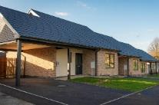 | - Work in partnership to deliver the City’s housing strategy to ensure that people are safe and linked to their communities  - Affordable Housing (grant) programme  - Increased use of private sector to alleviate/prevent homelessness | Number of new homes delivered across the city, including affordable properties  Improvements in the quality of housing stock across all tenures  Improved health and wellbeing of residents through housing related interventions/reduced homelessness  High quality and safe homes

VIBRANT
Reimagining our city centre with culture at its heart

There is an annual gross revenue budget of £7.1 million for delivering services within this priority area, with a net revenue budget of £5.2 million. The capital budget for a three-year period is £55.48 million.

Our outcomes | Our 2023/24 agreed areas of focus | The differences that you will see
Destination of choice, dynamic and diverse city centre | - Using our communication forums with tenants and their families we will promote the cultural offer and seek feedback to influence future offers  - Work alongside the Council and other partners to implement new models of housing and intervention to increase and improve inner city living with a particular focus on affordable housing  - Work alongside the Council and other partners to make our city centre feel safer | More people living within the city centre, with increased choice  Higher levels of satisfaction and customer experience with the city centre  Reduce levels of crime with more people feeling safe in the city centre  Reduction in void retail units  Improved housing options and choice

RESILIENT
Working with our communities to improve health, wealth and opportunities.

Our outcomes | Our 2023/24 agreed areas of focus | The differences that you will see
Empowered, strong and independent communities | - Facilitate a range of housing and support options that meet the city’s needs and provides suitable accommodation for the vulnerable  - Work in partnership to redesign locality services, with particular responsibility to deliver local priorities  - Reduced use of B&B for families experiencing homelessness  - Work to support our communities against the impacts of the cost of living crisis | Fewer people at risk of homelessness and more affordable housing and housing of a decent standard  Housing provision meets the needs of our customers  Community concerns are prioritised to improve outcomes within communities.  Better future outcomes for families  Better able to meet the needs of diverse communities  Better health outcomes for our citizens through targeted activity
Reduced inequalities, with healthier residents | - Work in partnership to streamline our processes implementing a coordinated approach to investing in our voluntary, third and faith sectors (co-production), building our communities and connecting people  - Continue to develop effective partnerships, locally and nationally continue the coordination of the City’s Homelessness Strategy – enhance preventative pathways for those at risk of rough sleeping. | More people in Derby have positive mental and emotional wellbeing through coordinated services  Improved facilities with more people being more active, leading healthier lives  Effective joined up approach to meeting need and supporting the most vulnerable.
A safe city, where those that need support can access them at the right time for them | - Deliver our priority programmes and projects  - Work with Childrens Social care to find solutions towards the sufficiency and sustainability of placements for our children in care.  - Work with Community Safety and Adult Social Care to review risk management/housing pathway for high-risk offenders.  - Support the development of a Supported Accommodation Review Team with oversight of non-commissioned supported exempt housing provision in the city. | More people reporting that they feel safe  Lower levels of domestic abuse and exploitation  A safer city where those that need support can access it at the right time.  High quality support and accommodation is available at the right time for those that need it.

WORKING SMARTER
Value for money is a consideration in everything we do
Working smarter and managing our services efficiently, effectively and economically

Our partnership outcomes | Our 2023/24 agreed areas of focus | The differences you will see
An intelligence led Council that delivers value for money  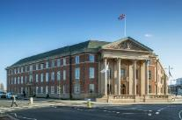 | - Improve our use of data, intelligence and feedback to shape the future of our services  - Ensure we maximise the use of partnerships to deliver services in our city  - Continue to develop our Digital Strategy  - Eliminate duplication and waste and maximise productivity | Improved insight available to support decision making in key areas  Greater co-ordination of services and better signposting and access for citizens  Solutions that help to achieve out outcomes  Efficiencies/Value for Money
Satisfied and enabled residents | - Embed a culture of Customer First  - Improve communication and engagement with our residents, to shape sustainable services for the future  - Increase the use of digitally enabled services  - Complete service access review | A culture where customers matter and are at the heart of our service  More residents and colleagues feeling informed and engaged – more positive feedback.  Increased digital transactions through My Account  Customers will be clear on where to access support, help and advice.
Empowered and accountable colleagues and Councillors | - Promote a culture of collaboration and working together  - Individual development plans in place for all employees – regular two-way communication  - Continue to communicate with councillors on a regular basis, respond to enquiries in a timely manner | Our colleagues are empowered to take personal responsibility for their development and career progression  Colleagues report that they feel empowered to make decisions  Councillors have a greater awareness of the work of Derby Homes and are respected in their role.

